Screenshot 1 – ArchOSC folder external
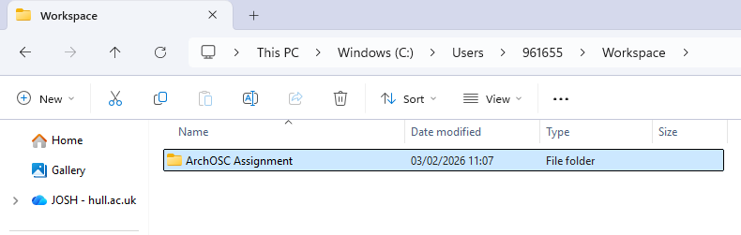
Screenshot 2 – ArchOSC folder internal
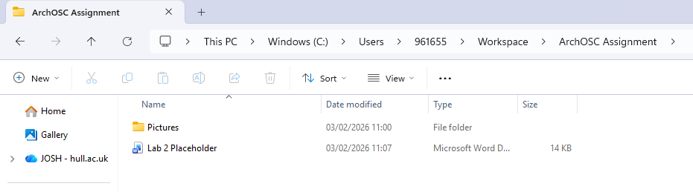
Created an assignment folder for saving details and progress related to my ArchOSC within the workspace folder of my user folder on the windows drive, file path ‘C:\Users\961655\Workspace\ArchOSC Assignment’. I Then created a folder within that assignment folder called ‘pictures’ that contains any relevant screenshots.
Screenshot 3 - CLI GIT Init
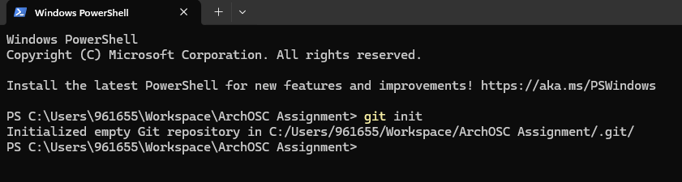
Used the GIT Init command to create a local repo in my assignment folder.
Screenshot 4 Online GIT Repo Created
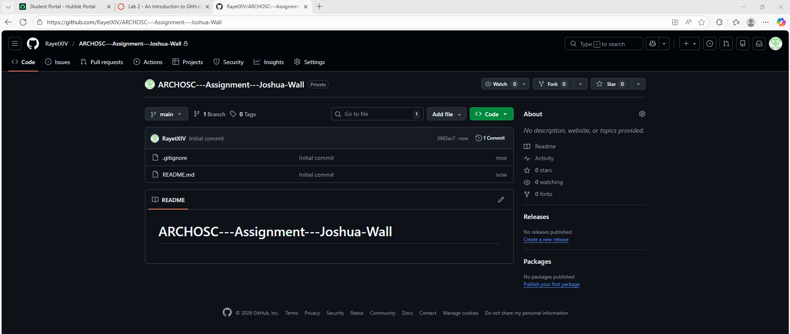
Created an online GIT repo to save assignment files too and use source control, Named as shown above, set to private, with a read me file and git ignore set to Visual Studio.
Screenshot 5 GIT Repo Pull
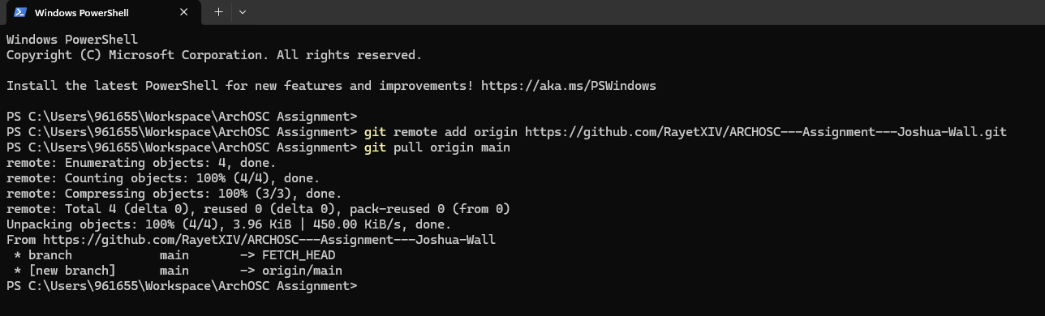I pulled the files, notably the empty read me and the Git ignore file, from the online repo to my local after linking the two through the CLI.
Screenshot 6 Basic HTML Setup
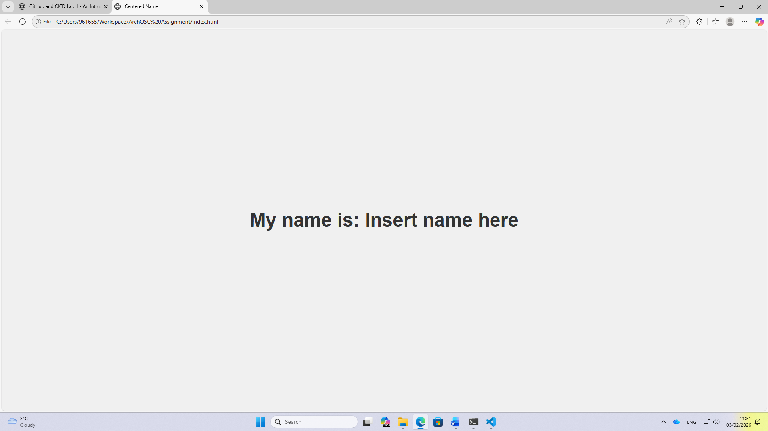
Using VS code and the HTML code provided I saved an index file that opens through edge to my repo folder so that then I commit and push it will be added to the online repo.

